**UNDERWATER IMAGE ENHANCEMENT**

**AMRITH JAGANATH G – 19BCE1138**

**ROHITH.M – 19BCE1086**

**YASHWWANTH B S – 19BCE1096**

**SCOPE**

**VELLORE INSTITUTE OF TECHNOLOGY**

**CHENNAI, INDIA**

**ABSTRACT:**

Underwater photos are a valuable source of information for learning about sea life and researching bottom hydrothermal vents. The main challenges that an underwater image has to deal with are low contrast, colour distortion, and a poor visual appearance. Light dispersion and refraction as it passes through rarer to denser medium generated these issues. Color contrast is reduced due to light dispersion. Water has an affect on underwater images due to dispersion as well as the presence of underwater species. Here, we present an enhanced underwater picture enhancement method based on the CLAHE method, which is capable of accurately restoring underwater images. The proposed work takes a single image as input and performs a series of operations on it, including white balancing, gamma correction, sharpening, and modifying weight maps.

**Keywords**-Image Enhancement, CLAHE, Histogram equalization, RGB

**INTRODUCTION:**

Underwater research is a good area since it escavates shipwrecks, which shed light on an ancient era, submarine use, marine life study, and so on. Due to light absorption and scattering, the underwater photographs have limited visibility. This reduces contrast and makes images blurry, making distant things appear misty. Because colour fading increases with increasing water depth, things that are more than 10 metres away from the sea top are more difficult to detect. There have been numerous attempts to recover and improve the quality of such deteriorated photographs. The results of multiplicative and additive approaches are usually the source of underwater scene limits. As a result, many enhancement techniques such as brightness enhancement, gamma correction, and histogram equalisation have limits when applied to this task. In the literature work, these challenges are addressed by strategies using multiple images, specialized hardware or polarization filters. Despite of their research works, these strategies still suffer from a number of issues that reduce their practical applicability. This paper introduces a method to improve the images taken deep in water. The work flow is depicted as follows. Initially the input image undergoes a white balancing operation. This white balanced image is gamma corrected and converted into a LAB color space. In the image enhancement process, CLAHE is performed and Luminance component of image is enhanced. This image is reconstructed to RGB color space. The same white balanced image is sharpened using unsharp masking and histogram equalization is applied to the enhanced image. Weight maps are calculated for the processed images. The input images and weight maps are fused using multiscale fusion.

**MOTIVATION:**

Software-based underwater picture enhancement solutions usually function by changing some feature of the underwater mathematical model to compensate for the degrading effects caused by water's light absorption and the presence of organic and inorganic particles in the water. Current state-of-the-art underwater image restoration methods are primarily intended for a single image input since processing multiple photos requires more computer resources and may not be suitable for real-time applications. Those based on picture fusion procedures exhibit the most promising results among the single image enhancing methods. The main premise of fusion-based approaches is to split the input image into two, process the split images independently, calculate weights based on the features of each image, and then fuse the images together using the determined weights.

**PROBLEM STATEMENT:**

The quality of an image captured in water is always degraded, according to this general observation. It lacks the tonal quality and contrast that are required to recognise the object of interest in the image. When the pixel intensity levels of neighbouring objects differ by only a few pixels, the issue becomes more difficult. This circumstance makes it difficult to extract finer details from the data and degrades the performance of the algorithms used to extract information from the images. As a result, there is a compelling need for underwater photos to be processed in such a way that they accurately depict their tonal subtleties. Underwater imagery has a wide range of uses, including aquatic life inquiry, water quality, defence and security, and so on. As a result, photographs or films obtained to achieve these aims must contain perfect information.

**LITERATURE SURVEY:**

Inorder to tackle the issue of bending and corruption in submerged pictures, a few strategies are talked aboutin writing. There are various procedures, for example, polarization based, spatial and tweak based strategies that reject the back dispersed light to work on the quality and differentiation of pictures.

[1] The techniques utilizing particular equipment utilize Lidar imaging. It utilizes laser innovation to catch submerged pictures in turbid water. The polarization of the light in the field of view is related distinctly with the backscatter. In these strategies, the pictures of same scene, is caught with various levels of polarization as is caught by a polarizing channel fitted on the camera.

[2] A versatile separating approach is acquainted with manage the commotion intensification of pixels. This functions as a programmed strategy for observing the medium conveyance and the regularization doesn't obscure close items. The impediment of polarization channels is that they are not relevant for video procurement,so they can't be utilized when dynamic scenes are thought of,

[ 3] In the strategy proposed by Narasimhan and Nayar a monochrome climatic dispersing model, that clarifies how scene forces are impacted by homogeneous climate condition is portrayed. For various scope of climateconditions like haze , hist and cloudiness, this model is substantial.

[4]Tarel and Hautiere clarified with regards to the differentiation degree of outside images.Here perceivability rebuilding is

performed from a solitary picture. Their proposed technique comprises of climatic shroud assessment, picture smoothing, tone planning and picture reclamation. The upside of the calculation is that,it can manage shading pictures just as dim scale pictures.

[5] Dim Channel Prior (DCP), has been proposed at first for open air scenes dehazing and later it was utilized for improving submerged pictures.

[6] G.Padmavathi et al. 2010

have analyzed and assessed three channels execution. They have involved diverse sifting procedures for submerged upgrade, for example, homomorphic channel, averaging channel, and nisotropic diffuision separating. The pre-handling of submerged pictures is finished with the assistance of these channels. These channels help to work on the nature of picture ,edge protection, commotion concealment and picture smoothening. The Wavelet denoising by normal channel gives exact outcomes as far as Peak Signal to Noise Ratio(PSNR) and Mean Square Error(MSE). [7]In Ancuti et al. an improvement technique is introduced where, a solitary info picture goes through gamma adjustment and honing. Distinctive weight maps are assessed. At long last multiscale combination is applied on the weight guides and info pictures to get an improved submerged picture.

**PROPOSED METHOD:**

Estimating White Balance

White balancing is the technique of removing colour casts from pictures. The overpresence of a certain colour in the scene when taking the image is known as colour cast or colour distortion in photos. Simplest colour balance, Grey world, Robust Auto White balance, and Sensor Correlation are the many colour balancing algorithms. Underwater, the influence of colour identification and recognition is proportional to the depth. The most important difficulty with underwater photographs is the greenish-bluish tint, which must be corrected.

Gamma Correction

An output is obtained after the white balancing process, which is then subjected to colour compensation. We apply gamma correction to the white balanced image since white balancing alone is insufficient to recover the absorbed colour in underwater photographs. The purpose of gamma correction is to restore global contrast, which is crucial because white balanced photographs appear to be overly bright in general. Gamma correction, on the other hand, has a tendency to lose image features in under/overexposed areas. A sharpening procedure can help to regain some of the features that have been lost.

Sharpening

The sharpening of the white balanced image is done in this module. Sharpening is performed using the unsharp masking. In Unsharp masking, a low pass version of the image is subtracted from the image itself obtaining an image with more finer details such as edges,corners, boundaries etc. Thus a high pass filtered image is obtained. It is done by the formula S = I + β(I - (G ∗ I)). where I is the image to sharpen, G ∗ I denotes the Gaussian filtered version of I, β is a parameter whose small value is not enough to sharpen the image and high value give rise to oversaturated region. Therefore the unsharp masking is done as follows:

S = (I + N {I − G ∗ I}) /2

Luminance Enhancement using CLAHE

Non-uniform illumination is one of the most difficult aspects of creating an underwater image. To get over this limitation, the image is enhanced in terms of luminance. In L*a*b* colour space, the gamma-corrected output of the white balanced image is subjected to brightness enhancement. The L*a*b* colour space is device-independent. L* stands for brightness, whereas a* and b* stand for chromaticity coordinates. CLAHE is applied to the L* component after it has been separated.

Multiscale Image Fusion

Multi-scale images combine enhanced sharped images, enhanced gamma corrected images, and weight maps. By using a weight map, the faults in these inputs can be reduced and the image quality can be improved to some extent. The inputs and weight maps are then fused on a multiscale basis.

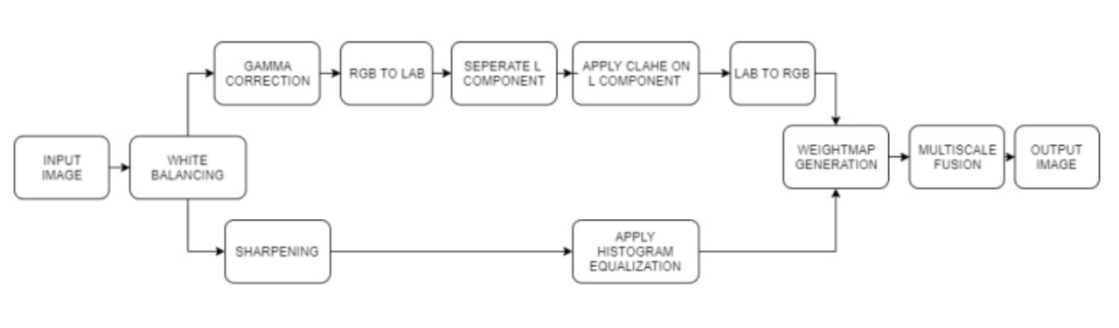

**EXPERIMENTAL SETUP:**

**HARDWARE:**

Windows 10, 64 bits (PC or Mac using Boot Camp) (Any CPU (Intel i5/ i7/ Ryzen 7).

Any GPU that is compatible with OpenGL 3.2.

Medium projects (100 images at 14 MP): 4 GB RAM, 10 GB HDD Free Space.

**SOFTWARE:**

MATLAB is a programming and numeric processing stage utilized by a large number of specialists and researchers to break down information, foster calculations, and make models.

**RESULT:**

The info picture is overwhelmed by a green tone. Preceding white adjusting, remuneration of the red and blue channel is finished. Second picture shows the redressed picture later the red and blue channel compensation,This is done because of the way that, Gray World calculation utilized for white adjusting has a serious red antiquity. Second column from left to right shows the white adjusted picture, the gamma amended picture and honed picture separately. The white adjusted picture has a cloudy nature. Inorder to defeat this, gamma rectification and honing is finished. The gamma remedied picture is changed over to LAB shading space. Then, at that point, Luminance part is separated and CLAHE is applied. Base column from left to right shows the result of CLAHE, Histogram Equalized picture and Multiscale melded yield individually. The further developed proposed strategy could uncover substantially more subtleties and designs contrasted and the current framework.

**CODE SCREENSHOTS:**

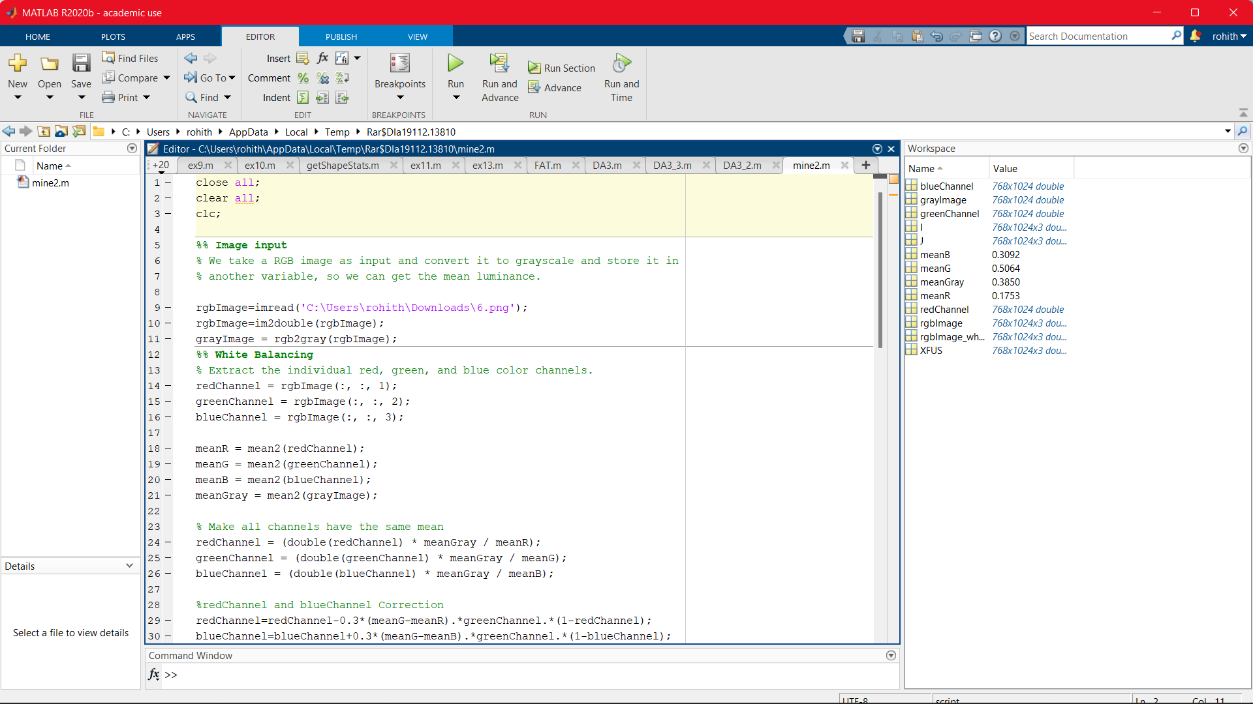

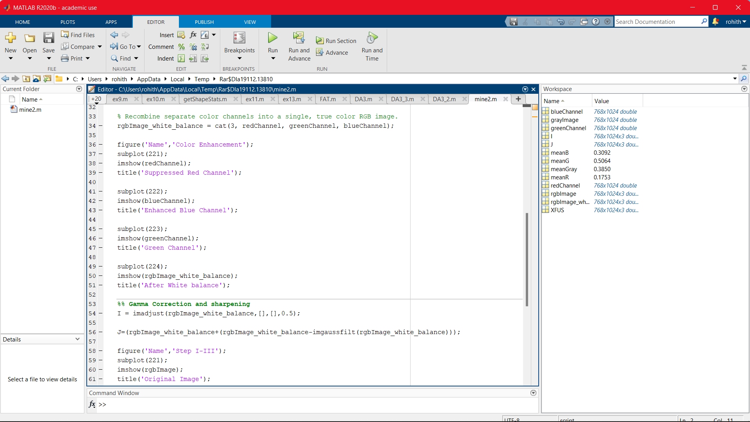

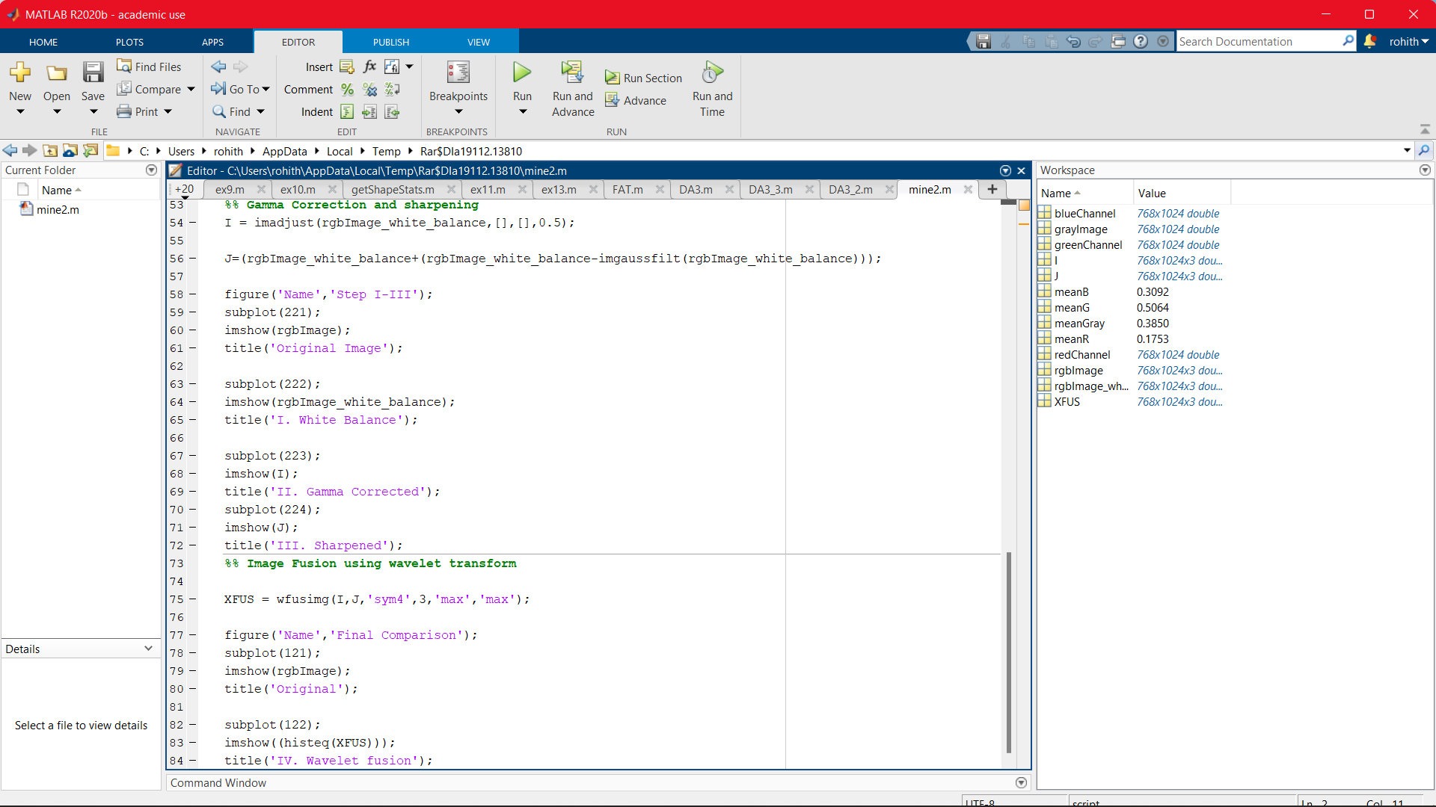

**OUTPUT SCREENSHOTS:**

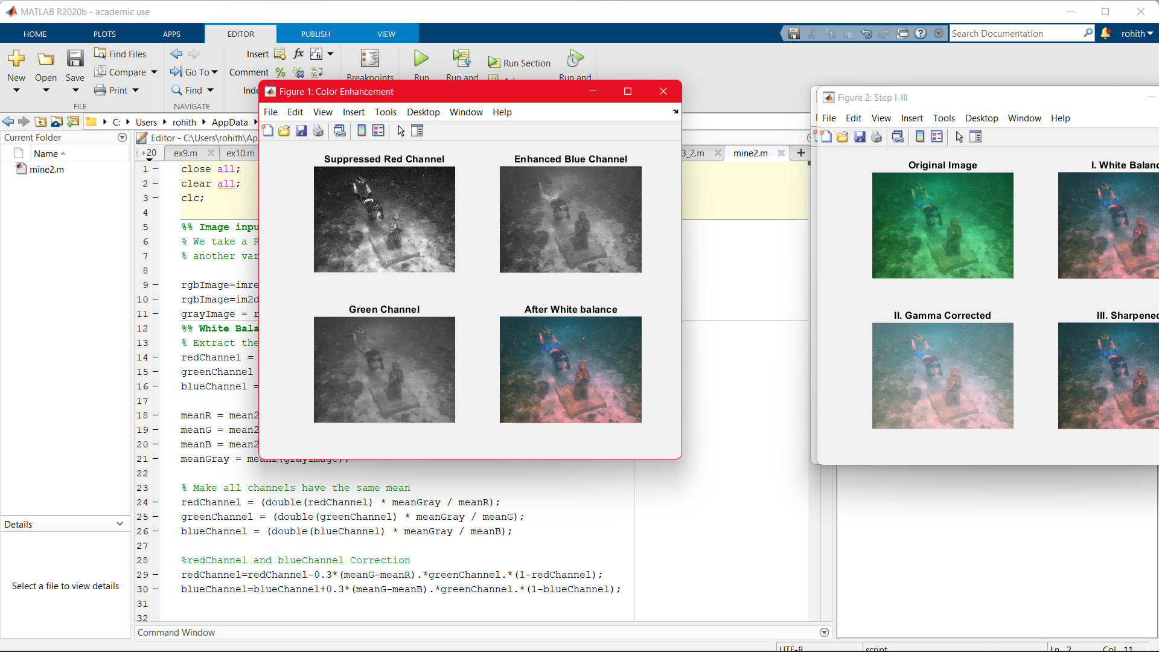

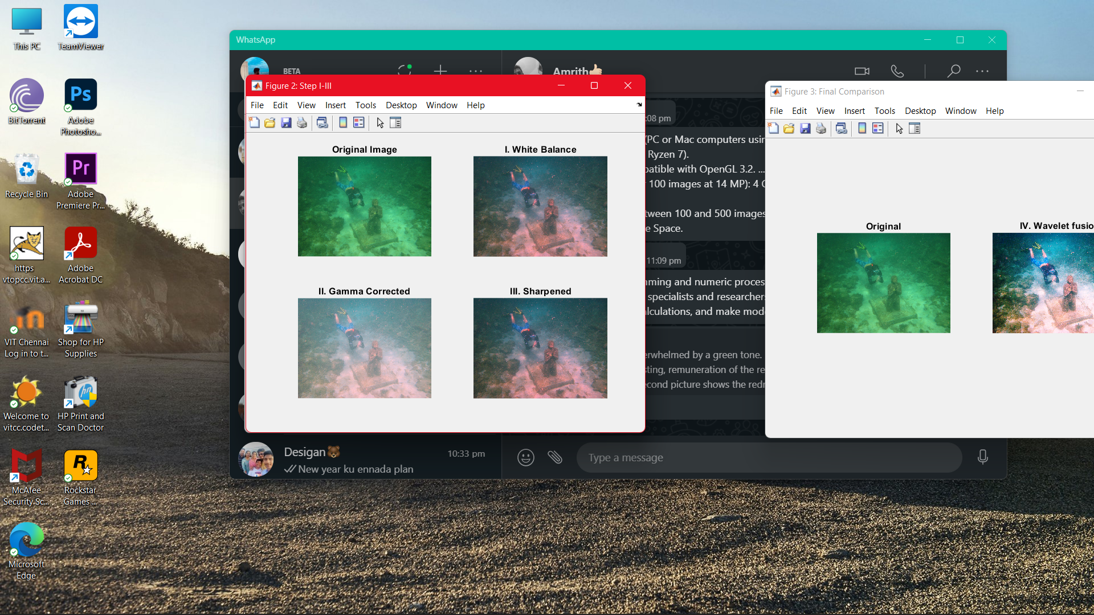



**CONCLUSION:**

The perceivability of articles a good ways off long or short in submerged scene is a major issue in picture handling. Despite the fact that, numerous techniques are accessible for picture upgrade, they have such countless constraints. The proposed strategy thinks about the upsides of multiscale combination and differentiation upgrade method. This technique doesn't need any extra data other than the single unique picture. This information picture is white adjusted furthermore this is arranged into two stages, first by playing out the gamma remedy and afterward honing. The result of this two techniques are exposed to an upgrade strategy. The weight guides of these data sources are determined. The interaction is trailed by a Multi Scale combination of the data sources and assessment of standardized weight guides to get the last improved result. The strategy is reasonable for recuperating the critical elements and edges which have been blurred. The trials showed that the proposed technique works on the visual nature of submerged pictures. To support submerged picture handling, a reasonable information base of test pictures for various imaging conditions is as yet required. More examinations must be done to conquer the issue of shading reclamation for the pictures taken from a more noteworthy distance in submerged.

**REFERENCE:**

[1] D.-M. He and G. G. L. Seet, “Divergent-beam LiDAR imaging in turbid water,” Opt. Lasers Eng., vol.41, pp. 217–231, Jan. 2004

[2] Y. Y. Schechner and Y. Averbuch, “Regularized image recovery in scattering media,” IEEE Trans. Pattern Anal. Mach. Intell., vol. 29, no. 9,pp. 1655–1660, Sep. 2007

[3] S. G. Narasimhan and S. K. Nayar, “Contrast restoration of weather degraded images,” IEEE Trans. Pattern Anal. Mach. Learn., vol. 25, no.6,pp. 713–724, Jun.[4] J.-P. Tarel and N. Hautiere, “Fast visibility restoration from a single color or gray level image,” in Proc. IEEE ICCV, Sep. 2009, pp. 2201–2208

[5] K. He, J. Sun, and X. Tang, “Single image haze removal using dark channel prior,” in Proc. IEEE CVPR, Jun. 2009, pp. 1956–1963.

[6] Dr.G.Padmavathi, Dr.P.Subashini, Mr.M.Muthu Kumar and Suresh Kumar Thakur. “Comparison of Filters used for Underwater Image PreProcessing” IJCSNS , 2010

[7] C. A. C. O. Ancuti, “Color balance and fusion for underwater image enhancement,”IEEE Trans. Image Process., vol. 27, no. 1, January 2018